The Lady Anne Windsor Charity
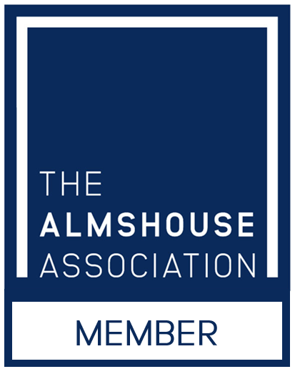
What we do
The Lady Anne Windsor Charity is an almshouse charity. It originates from the almshouses on the Downs in Stoke by Nayland, built by Lady Anne in around 1610 and established as a Trust in her will.
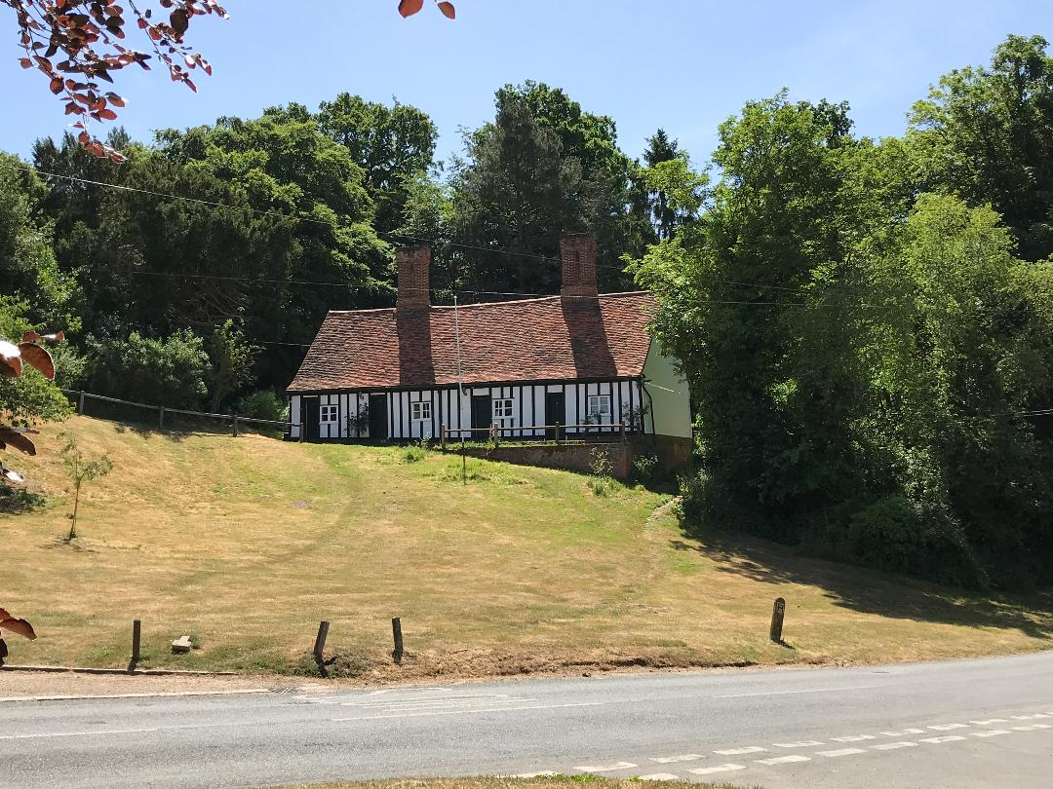
They continue to provide low-cost accommodation for four single people, in an area where such accommodation is as rare as hens’ teeth.
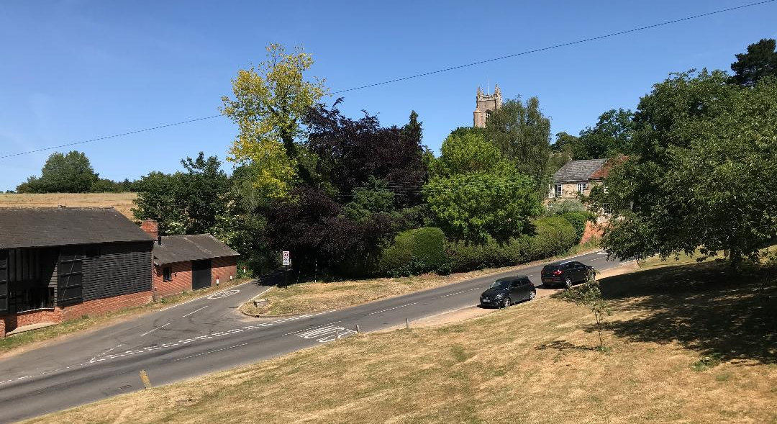
The view from Downs almshouses
As a charity, it is regulated by a Scheme of the Charity Commission (generally referred to as our Governing Document) and its resources must be devoted to its charitable purpose, which is to provide housing for “poor persons who are inhabitants of the area of the Civil Parishes of Leavenheath, Nayland-with-Wissington and Stoke-By-Nayland with a preference for women”.
It has ambitions to increase the housing it can provide. In 2016 LAWC acquired No.3 Rowley Cottages, by the churchyard in Stoke, from Babergh District Council. Development projects are described below.
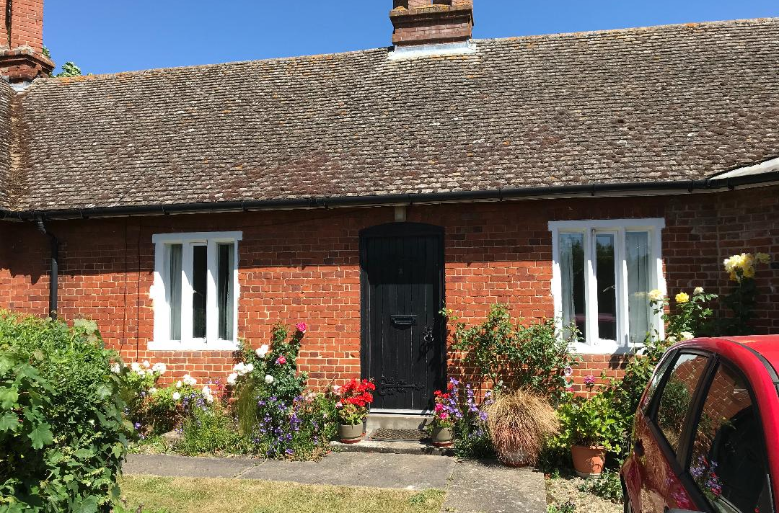
No.3 Rowley Cottages
Who we are
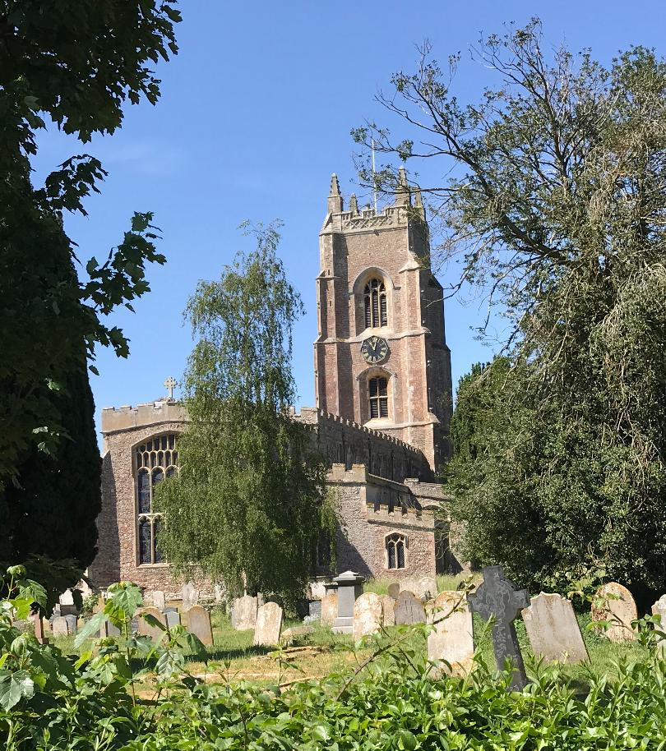
LAWC is the responsibility of five Trustees. Two are nominated by Stoke by Nayland Parish Council, and all are required to be “persons who through residence, or occupation or employment, or otherwise have special knowledge of the area” of the three Parishes.
Adam Sedgwick (Chairman) – nominated by the Parish Council
Janet Bosman
Nicki Bray – nominated by the Parish Council
Peter Orrock
Martin Owen
The Trustees are assisted by their Clerk.
This now works as a husband and wife job share:
Anne & Colin Walton
Great Gable
Scotland Street
Stoke by Nayland
Colchester
CO6 4QE
Tel: 01206 262266
Email: colin.anne@btinternet.com
The view from 3 Rowley Cottages
Vacancies
Years can go by without any of our properties becoming vacant. So we don’t keep a waiting list, and indeed our Governing Document lays down that no appointment of a resident shall be made by the Trustees until a sufficient notice of a vacancy has been published in local media. Nowadays, this means essentially the LSPN.
Why almshouses are special, and why we want more of them.
Because there is crying need for good quality accommodation for local people who cannot afford open market housing.
Because we are barred from housing other than inhabitants of the three parishes, the local communities know that our own housing will always be for local people.
Because our housing is only for those who can’t afford open market housing, we are always meeting a need commercial housing cannot.
Because almshouses are exempt from right-to-buy, our housing will always remain for local people who can’t afford open market housing.
Because we are responsible for our properties in perpetuity, we have a direct interest in them being good quality and remaining so.
Because, when we have a development project, any building for sale can be only to balance the books, the proportion of affordable housing in any project will be much higher than a commercial development.
Because we retain an interest in any site we develop, we can impose and enforce covenants on properties built for sale.
All this means that the local communities have compelling reason to regard us more favourably than ordinary developers and owners of rental property.
Our development projects
We continue to work with Suffolk County Council and Hastoe Housing Ltd towards development of part of the site of the former Stoke by Nayland Middle School. The intention is to make a planning application in the summer of 2020.
We own a field in Leavenheath. This presents a unique opportunity to develop new accommodation to meet local needs by working in close conjunction with the Leavenheath Parish Council and Babergh District Council.
During 2019 we became aware of the opportunity of government grants to remodel the historic almshouses on The Downs. We have appointed an architect and a project manager, and plan to take this forward in 2020.
Contact us
Clerk to the Trustees
Anne & Colin Walton
Great Gable
Scotland Street
Stoke by Nayland
Colchester
CO6 4QE
Tel: 01206 262266
Email: colin.anne@btinternet.com

